Requirement for QDC

1. Add Enter Postcode where circled. Use the Current Api which is already attached. A person in a suit

   Description automatically generated with medium confidence

Enter Postcode



* Similar as Valet Dry Cleaners Style. But there should be no extra box. Copy same out as VDC.

1b) When customer enters post codes SN1, SN2. SN3. When he clicks on Book now a popup message should appear Dear Customer – Minimum Order is £25.00 for this Post Code Area. Cancel Button & Next Button. If he clicks on Next button, he then chooses collection Date & Time.

2b) When customer enters SN4 | SN5 | SN6 | SN7 | SN16 | SN25 | SN99 & SN38 popup message should appear Dear Customer – Minimum Order is £25.00 for this Post Code Area. Cancel Button & Next Button. If he clicks on Next button, he then chooses collection Date & Time. similar as below pic

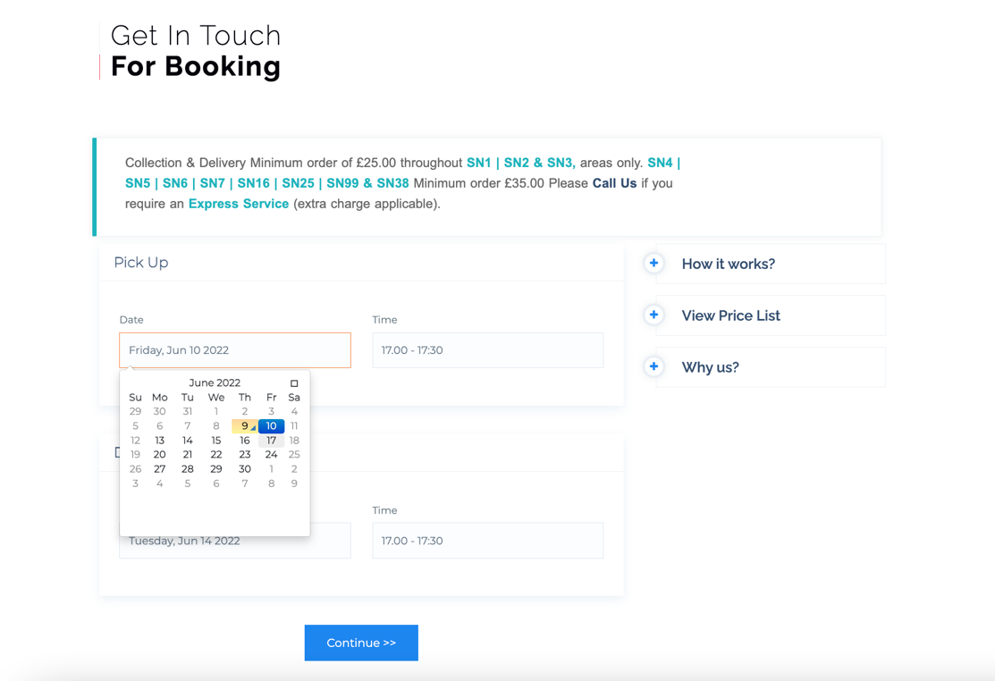

if SN1 5PL via post code IS SELECTED REMOVE THE TEXT AND ONLY SHOW here Minimum Or*der is £25.00. Please Call Us if you require an Express Service (extra charge applicable).*

* Calendar Remains the same.
* Remove Get in Touch For Booking and Change to **Choose Collection Date & Time.**

1. Price List Page should be next once customer has chosen date of collection and Delivery Date.

* Should have 3 columns
* Only + & - Button
* Skip item selection button should also appear if selected takes you straight to the next page which is confirmation of the collection & delivery address etc.
* categories should be the same as mine.
* Have different images selection via dashboard.
* Graphical user interface, application

  Description automatically generated

Keep info same as above whatever the post has been entered shows Collection & Delivery Minimum order of £25.00. etc

Total Price from the Pricelist Page Basket should show here. Create another box.

When address is selected in the home page it should be auto entered here in this field.

* 1st line such as 93 Windsor Road
* City: Swindon
* Post Code: SN3 1LG

1. Make sure all fields have been entered before you can confirm if any missing gives error also have invisible catche to avoid spams bookings.

1. once customer hits confirm a popup message should appear with a Thank You for arranging a booking, Collection. Booking Reference number should change on every order.

* Once popup clears or have a button Okay the fields should reset. Customer can then either close the page or go to home page by clicking the top bar homepage.

1. Shop Prices & Delivery Prices have same layout as new pricelist layout like the Booking Page pricelist once Done.
2. Add WhatsApp Button. WhatsApp number +447599091665.
3. Fix the Home page contact Form.

* Missing Invisible captcha
* fix Thank You for Contacting Us message. Should appear quick currently takes 5min to appear.

1. also have Invisible captcha on the booking form aswell to avoid spam bookings.
2. In Footer: Remove Temporary Opening Hours and replace with Opening Hours.

* Monday – Friday 8.30am – 5.30pm
* Saturday 9am – 5pm
* Sunday Closed
* Bank Holidays Closed.
* Christmas: 24th – 1st

1. Special Offers make this area more eye catching so the offers are easier to be read. currently to small images.
2. Dashboard panel, to update prices and categories add new one and delete categories.